1)CLASS DIAGRAM:
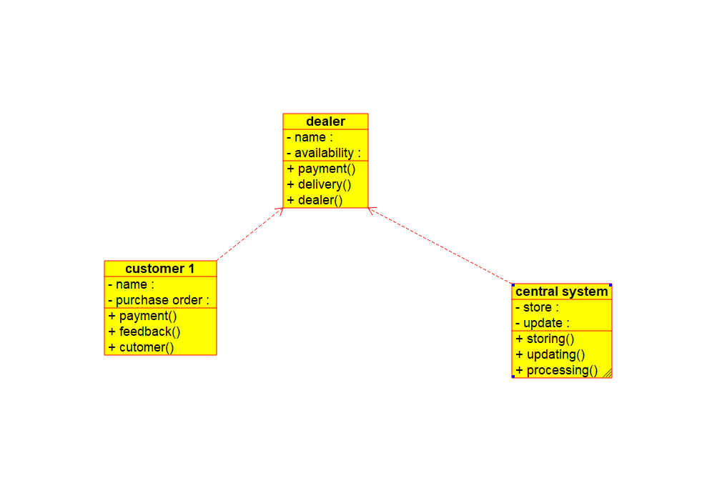
2)COMPONENT DIAGRAM:
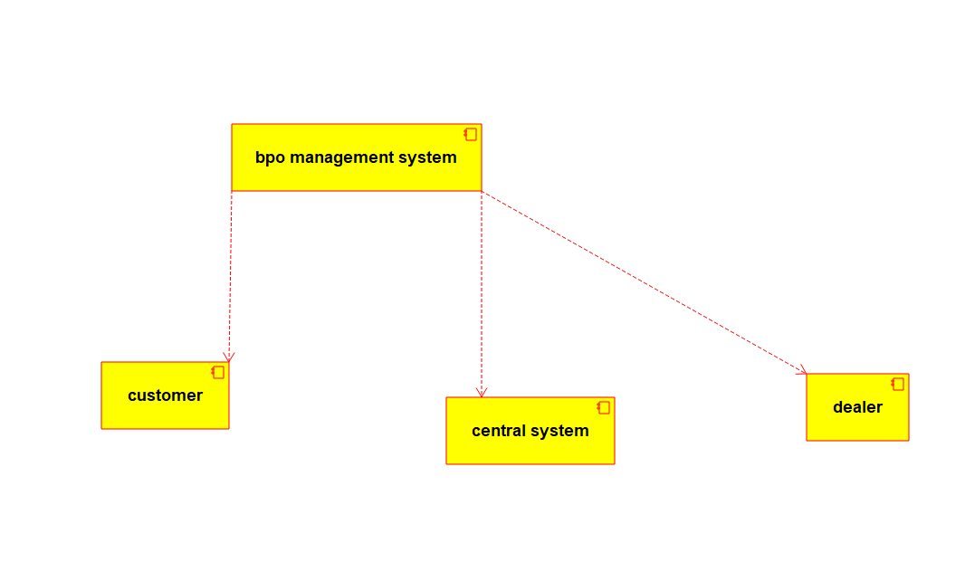

3)DEPLOYMENT DIAGRAM:
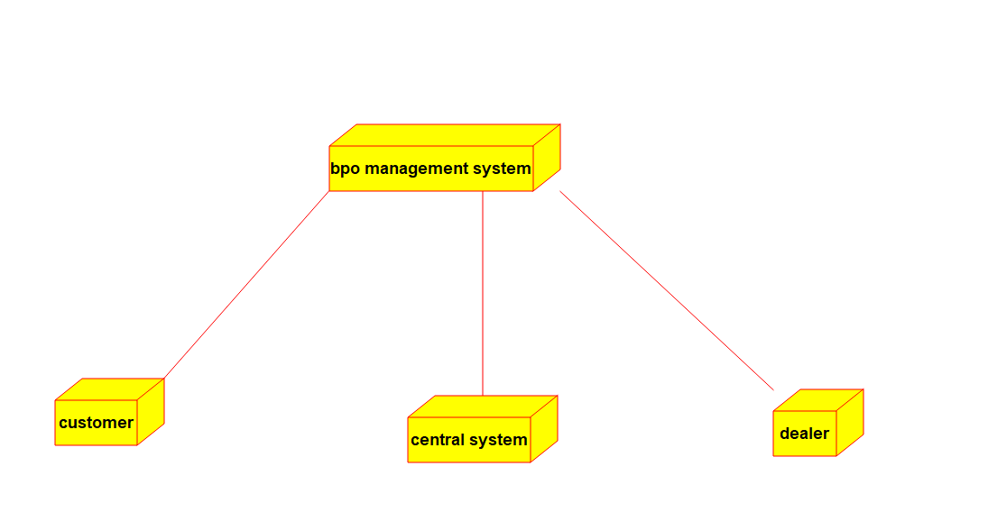
4)USE CASE DIAGRAM:
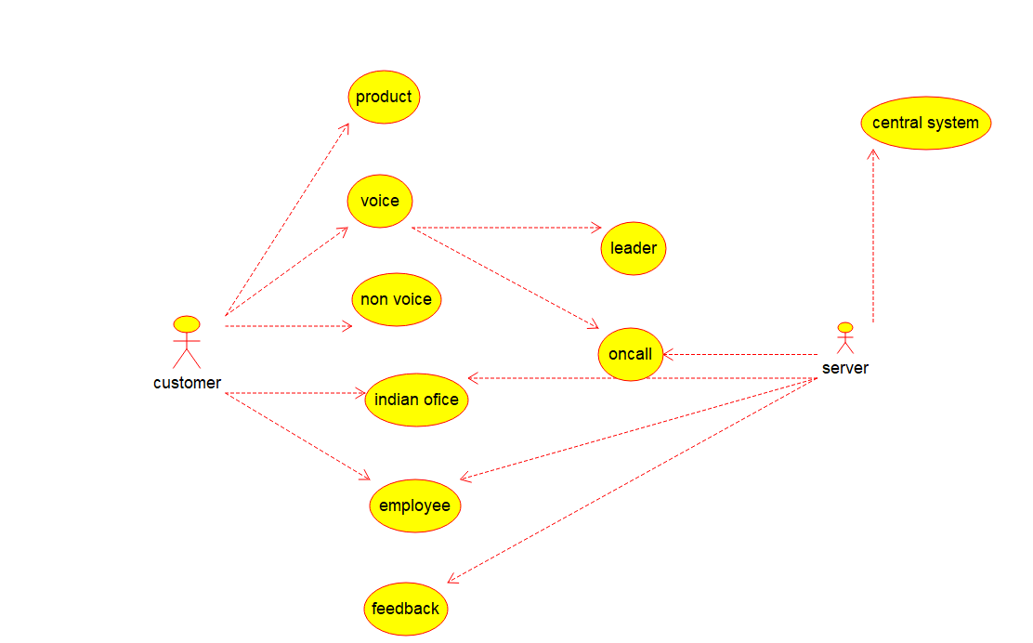

5)STATE DIAGRAM:
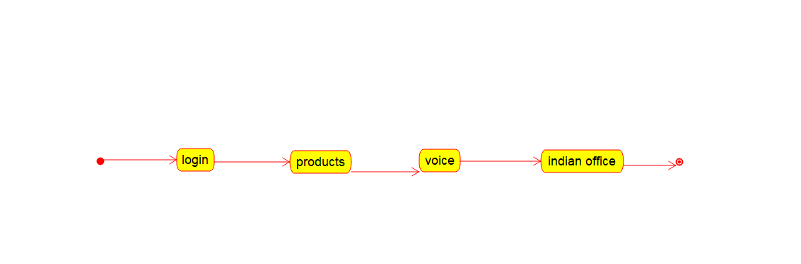

6)PACKAGE DIAGRAM:
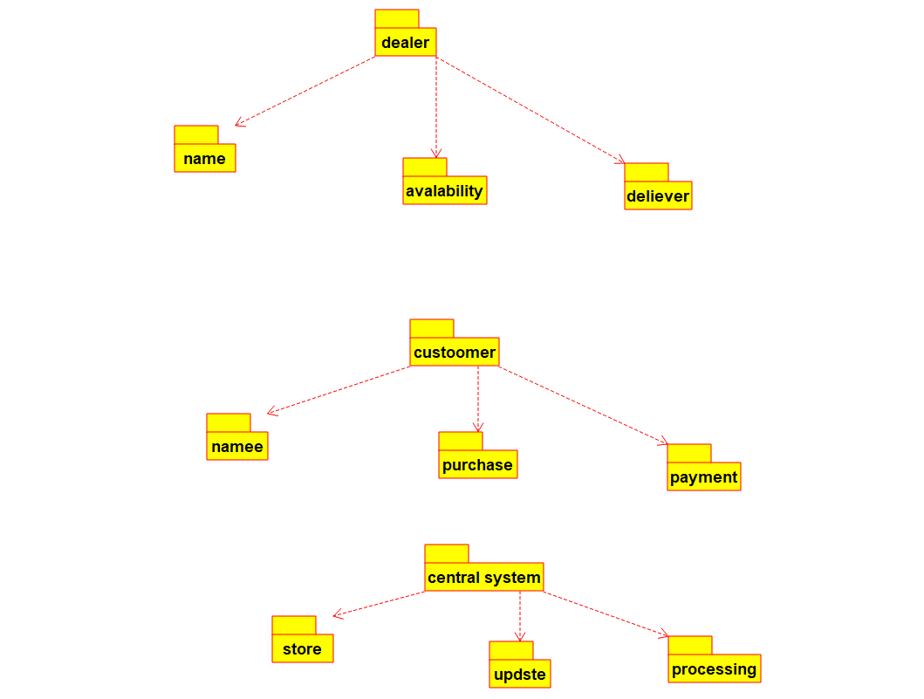

7)COMMUNICATION DIAGRAM:
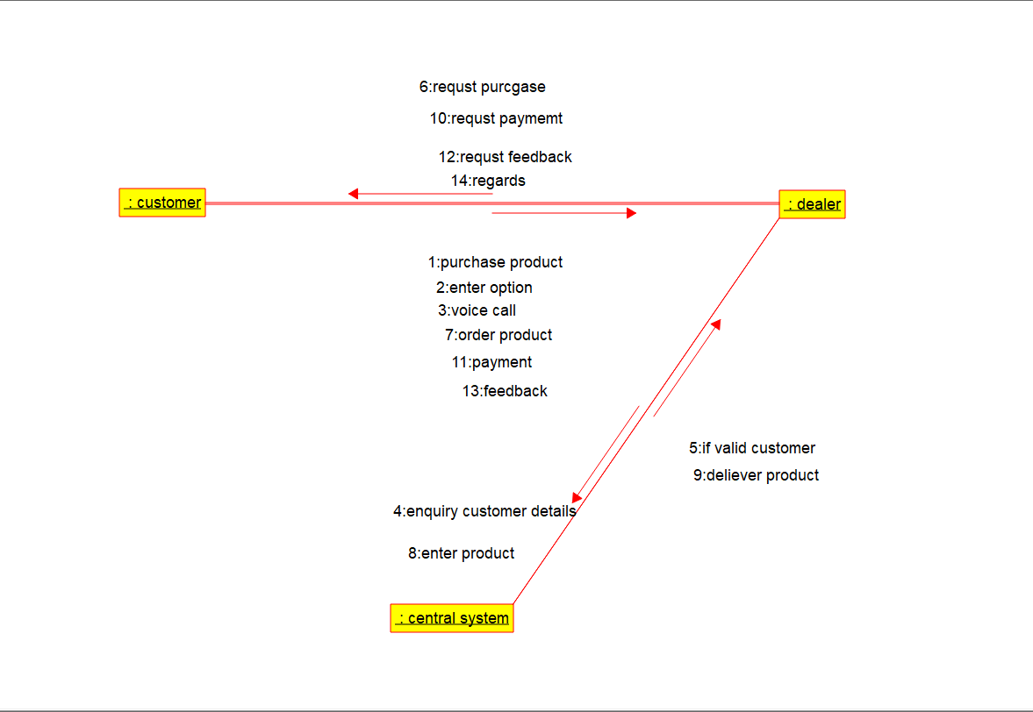
8)SEQUENCE DIAGRAM:
